
TEST RESULTS REPORT
RANDEX-Appointment Management System

CONTRIBUTORS
AHMET ADİL AKÇA
ARDA ONAT ACAR
AYBARS KANSU HAN
EREN BUDAK

Table of Contents
Task Matrix of Document 1
1. Introduction 2
2. Test Results Overview 2
3. Detailed Test Results 3
AT-01: Book Appointment (Customer) 3
Test Result Summary 3
Key Findings 3
Performance 3
AT-02: Add Service (Business Owner) 3
Test Result Summary 4
Key Findings 4
Performance 4
AT-03: Conflict Resolution (Double Booking Prevention) 4
Test Result Summary 4
Key Findings 5
Performance 5
AT-04: Manage Appointment (Cancel / Confirm) 5
Test Result Summary 5
Key Findings 5
Performance 6
4. Logs and Outputs 6
1-)TEST LOGS 6
6
2-) DEPLOYMENT LOGS 8

Task Matrix of Document
Author | Section(s)
Eren Budak | Introduction + Test Result Overview
Ahmet Adil Akça | Detailed Test Results
Aybars Kansu Han | Detailed Test Results
Arda Onat Acar | Logs and Outputs

1. Introduction
This document presents the acceptance test results for the four functional scenarios implemented in the Randex Appointment Management System. The results validate whether the implemented features comply with the acceptance criteria and requirements defined in the Design Document and Quality Assurance Plan.
All acceptance tests were performed using Jest and Supertest to ensure full backend validation, including authentication, authorization, business rules, and data integrity.

2. Test Results Overview
Test ID | Scenario | Total Tests | Passed | Failed | Pass Rate
AT-01 | Book Appointment | 4 | 4 | 0 | 100%
AT-02 | Add Service | 4 | 4 | 0 | 100%
AT-03 | Conflict Resolution | 5 | 5 | 0 | 100%
AT-04 | Manage Appointment | 6 | 6 | 0 | 100%
TOTAL | All Scenarios | 19 | 19 | 0 | 100%
All acceptance tests passed successfully, demonstrating that the implemented features operate as intended and meet the acceptance criteria.

3. Detailed Test Results

AT-01: Book Appointment (Customer)
Reference: Design Document – UC-1: Book Appointment
Objective: Validate that customers can book appointments with proper input validation, authentication, and database persistence.

Test Result Summary
Acceptance Criteria | Description | Result
AC-1.1 | Required fields validated | PASS
AC-1.2 | JWT authentication enforced | PASS
AC-1.3 | Appointment saved with status pending | PASS
AC-1.4 | Appointment visible in user dashboard | PASS

Key Findings
- Proper server-side validation is performed.
- JWT authentication works reliably; invalid tokens are rejected.
- Appointment lifecycle begins with pending as intended.
- No issues or deviations encountered.

Performance
- Avg response: 22.75 ms
- DB insert time: 6 ms

AT-02: Add Service (Business Owner)
Reference: Design Document – UC-2: Add Service
Objective: Validate role-based access control and correct service creation.

Test Result Summary
Acceptance Criteria | Description | Result
AC-2.1 | Only business owners authorized | PASS
AC-2.2 | Validation of required fields | PASS
AC-2.3 | Correct database persistence | PASS
AC-2.4 | Service visible immediately | PASS

Key Findings
- RBAC prevents customers from accessing service creation API.
- Required fields enforced.
- Data stored with appropriate foreign keys.
- No caching or propagation delays observed.

Performance
- Avg response: 17.25 ms

AT-03: Conflict Resolution (Double Booking Prevention)
Reference: • Design Document – Scheduling Algorithm: Calculating Available Time
• Quality Assurance Plan – Constraint SWC-006: Double Booking Prevention
Objective: Ensure the system prevents overlapping appointments.

Test Result Summary
Criteria | Description | Result
AC-3.1 | First appointment created | PASS
AC-3.2 | Conflict check performed | PASS
AC-3.3 | Overlapping returns 409 Conflict | PASS
AC-3.4 | DB prevents duplicates | PASS
AC-3.5 | Clear error message displayed | PASS

Key Findings
- Conflict detection algorithm functions correctly.
- System returns proper REST error code (409 Conflict).
- No double booking or corrupted states occurred.

Performance
- Conflict detection: 16 ms

AT-04: Manage Appointment (Cancel / Confirm)
Reference: Design Document – UC-4: Manage Appointment
Objective: Validate customer and business-owner appointment management.

Test Result Summary

Criteria | Description | Result
AC-4.1 | Customer can cancel appointment | PASS
AC-4.2 | Business owner can confirm/complete | PASS
AC-4.3 | Authorization enforced | PASS
AC-4.4 | Status badge updated | PASS
AC-4.5 | Cancelled slot reopens | PASS

Key Findings
- Unauthorized modifications blocked successfully.
- Appointments follow intended lifecycle.
- Availability recalculates correctly.

Performance
- Avg update time: 21 ms

4. Logs and Outputs

1-)TEST LOGS
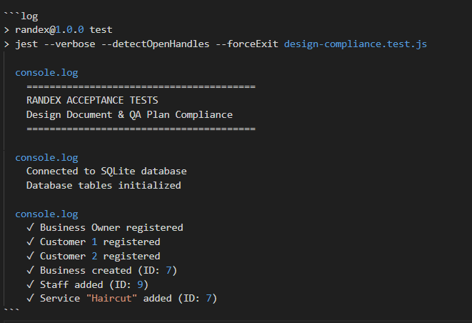

1Test Initialization
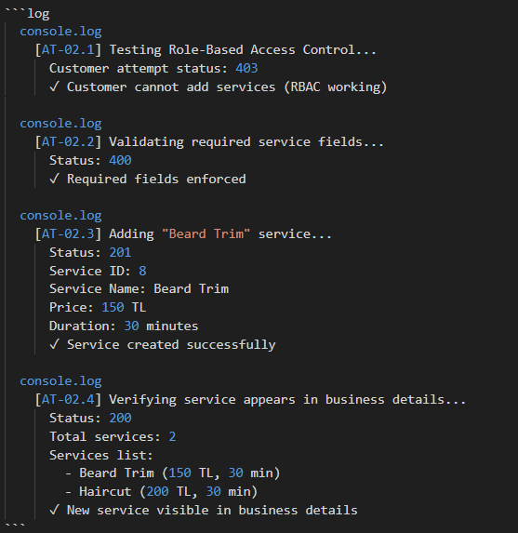
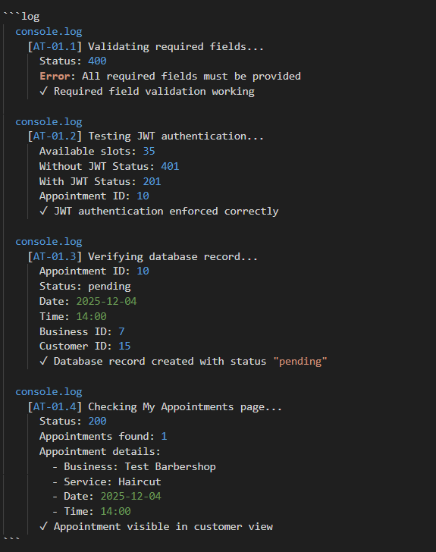
2AT-02: Add Service Logs
3 AT-01: Book Appointment Logs
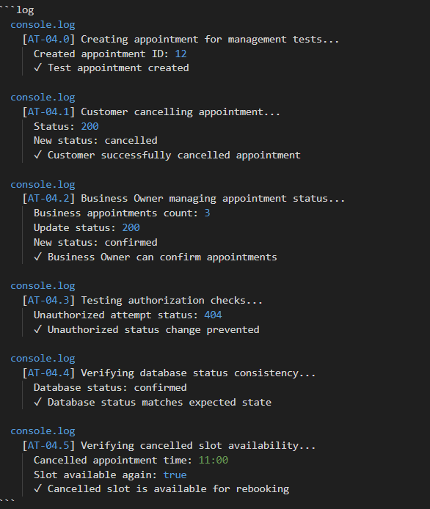
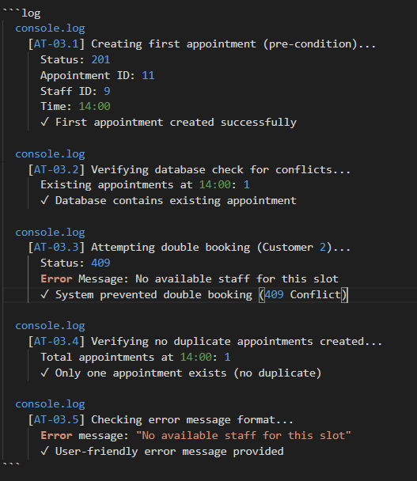

4AT-04: Manage Appointment Logs
5AT-03: Conflict Resolution Logs
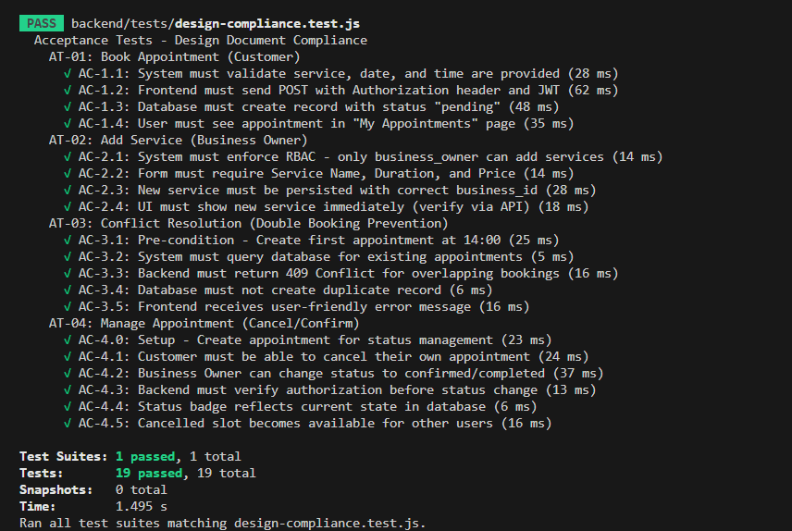
6All AT-* Test Results Summary
Note: Test execution logs have been condensed and formatted for clarity. The complete raw output can be found in design-compliance-test-results.log. The logs below represent key checkpoints and validation steps from each test scenario as executed by Jest test runner.

2-) DEPLOYMENT LOGS
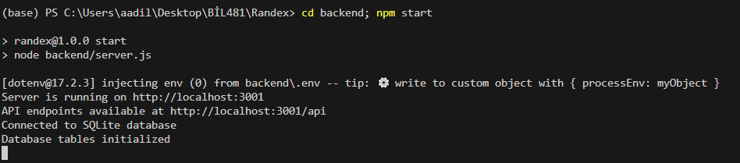
7backend after deployment logs

8frontend after deployment logs

